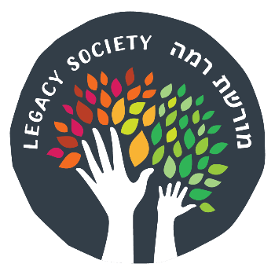

Moreshet Ramah (רמה מורשת) Legacy Society
Legacy Gift Confirmation

I, , of , confirm that I
(First Name, Middle Initial, Last Name) (City) (State) have provided for a legacy gift to benefit Camp Ramah in the Poconos, Ramah Day Camp, and
their Tikvah programs.
I have specified this gift within my estate plan and have made the appropriate arrangements to ensure that this will be accomplished on or about the time of my passing. This Legacy Gift Confirmation is not a legal obligation and may be changed at my discretion at any time.
My commitment is acknowledged within the following document (please choose one):

Bequest in Will
Charitable Remainder Trust

Beneficiary of a Life Insurance Policy Charitable Lead Trust
Beneficiary of a Retirement Plan Cash Endowment Gift (Cash, securities, etc.)

Other (please describe):

I am pleased to be able to support Camp Ramah in the Poconos, Ramah Day Camp, and their Tikvah programs through this legacy gift.

The approximate value of my commitment will be $__ ______or_____% of our estate.

Donor Signature Date

OPTIONAL: Assistance to provide for my legacy commitment given by (Please designate adviser):

Estate planning attorney: Financial planner:
Phone: Phone:
Other:

I would like my name to appear in lists of Moreshet Ramah Legacy Society members as:

_________________________________________________________________________

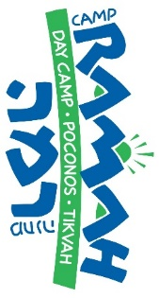
PLEASE COMPLETE & RETURN THIS FORM TO:
Miryam Seid, Director of Institutional Advancement
Camp Ramah
7 Bala Ave, Suite 103
Bala Cynwyd, PA 19004

Contact us at 215-885-8556 or miryams@ramahpoconos.org Visit ramahpoconos.org for more information

