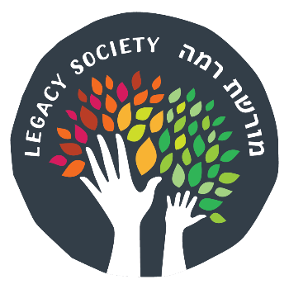
Moreshet Ramah (רמה מורשת) Legacy Society
Confidential Statement of Intent

I/we will make a provision for Camp Ramah in my/our estate plan as a way of ensuring the future strength and vitality of Camp Ramah in the Poconos and its mission to create life-long Jewish connections, one happy camper at a time.

_______________________________________________ _______________
Name (Please Print) Date of Birth

_______________________________________________ _______________
Name (Please Print) Date of Birth

_______________________________________________________________________________________
Address City State ZIP

____________________________ ___________________________________________
Telephone Email

Description of the gift:

- Bequest in will or trust
- Beneficiary of life insurance policy
- Beneficiary of retirement plan
- Charitable Gift Annuities

- Charitable Remainder Trust
- Real Estate
- Other________________
- Uncertain at this time; TBD

Publication and Communication
Camp Ramah in the Poconos periodically publishes a list of Legacy Society Members, unless members request to stay anonymous. Publishing your intention encourages others, by means of your example, to make similar gifts. All details about type or amount of each member’s intention will remain confidential.
- Please list my/our name(s) as: ______________________________________________
- Please do not publish my/our name(s) in connection with Camp Ramah’s Legacy Society.

This statement of intent does not constitute a legally binding pledge or agreement for me or for my estate. It documents my intent, and may be amended at any time.

______________________________________________________________ ____________
Signature Date

______________________________________________________________ ____________
Signature Date
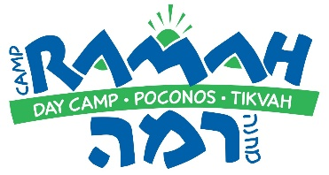
Please return this form to:
Miryam Seid
Camp Ramah in the Poconos
7 Bala Ave, Suite 103
Bala Cynwyd, PA 19004

